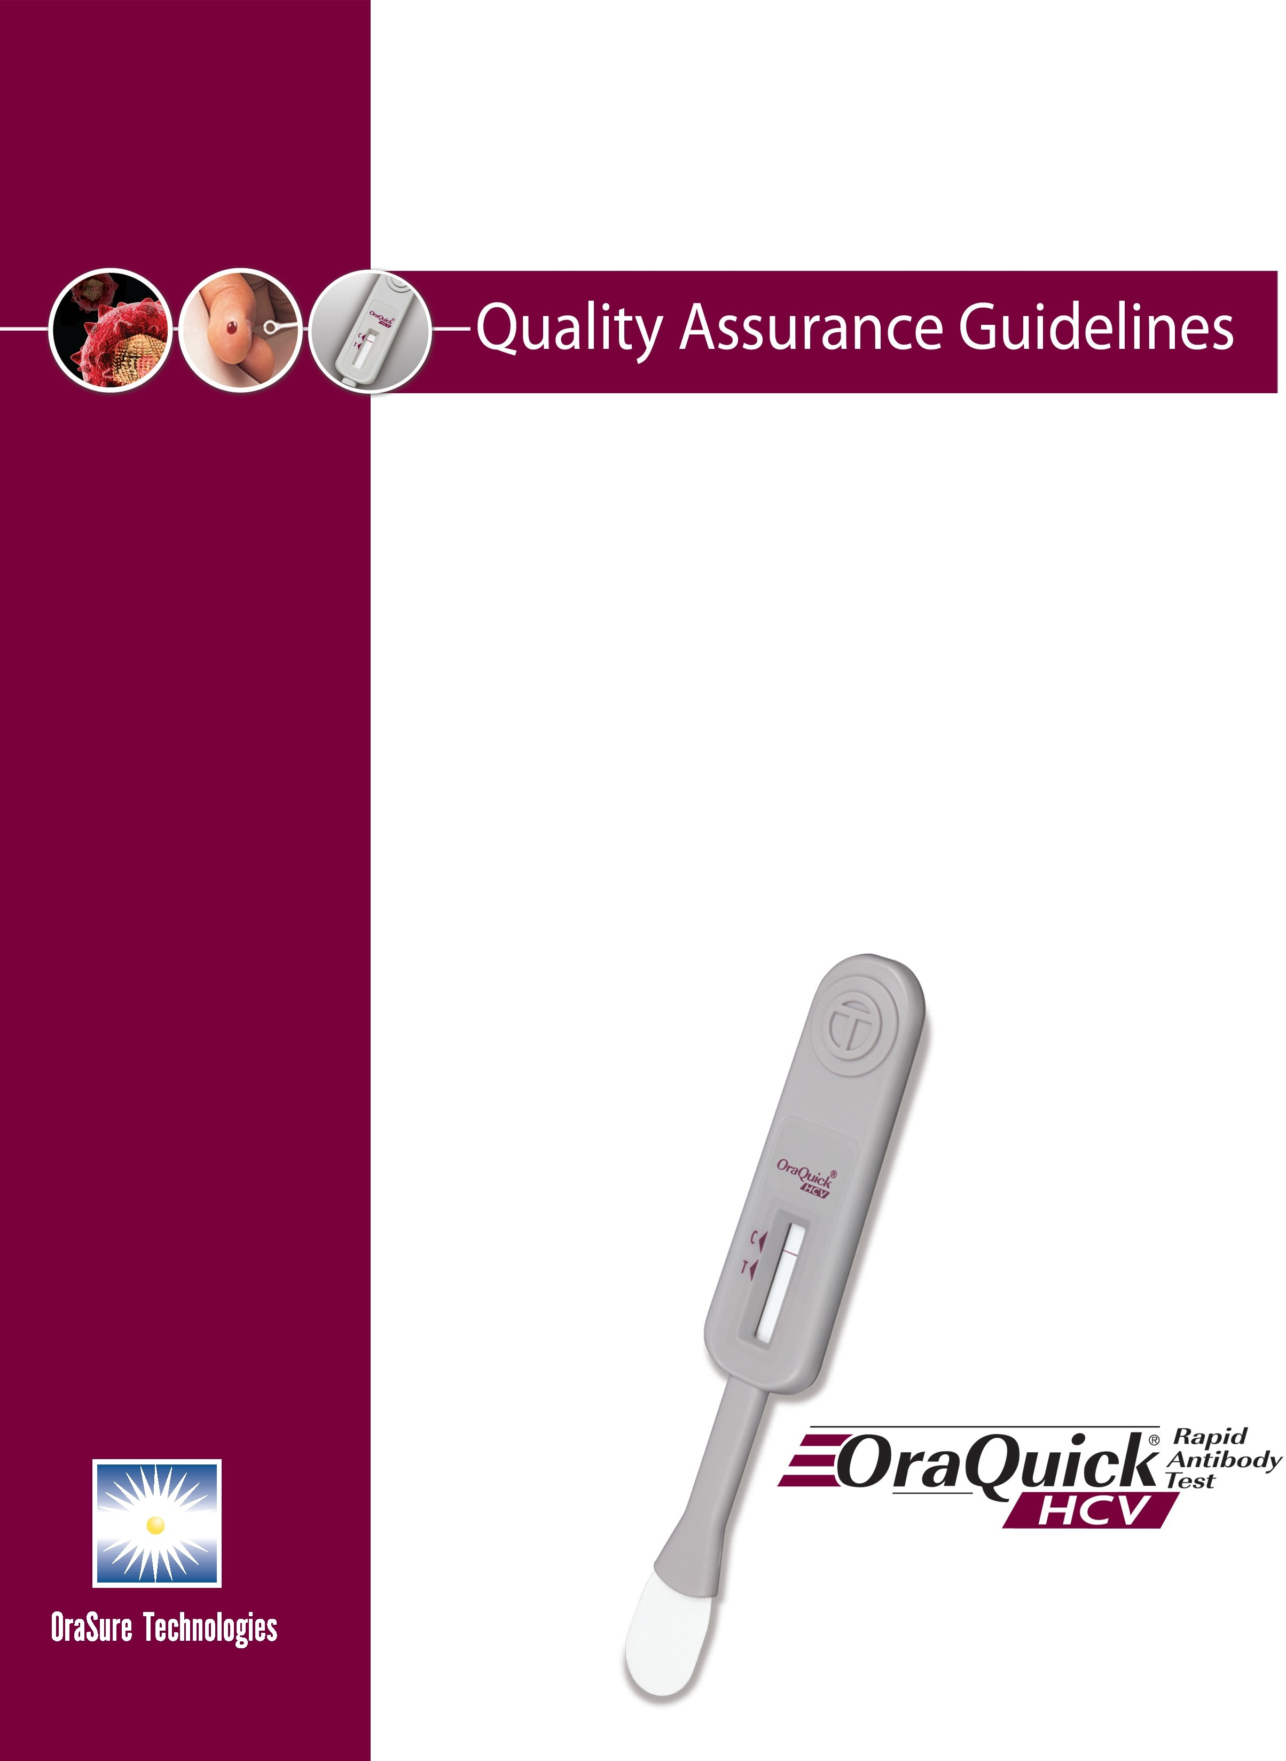
OraQuick® HCV Rapid Antibody Test

Quality Assurance Guidelines for Testing Using the OraQuick® HCV Rapid Antibody Test



This document has been modified by OraSure Technologies from its original document “Quality Assurance Guidelines for Testing Using the OraQuick® Rapid HIV-1 Antibody Test” authored by the CDC and other individuals found on Internet site: http://wwwn.cdc.gov/cliac/pdf/Addenda/clia0903/C-GuidlinesOraQk.pdf.

The edits contained in these Quality Assurance Guidelines reflect suggested changes for purposes of establishing a Quality Assurance Program with the OraQuick®
HCV Rapid Antibody Test. These changes have been provided as a guide in an effort to maintain the integrity and intent of the original document. These edits do not necessarily express the views of the original authors.

©2007, 2011 OraSure Technologies, Inc. Item# HCV0068 (rev. 06/11)

Introduction and Background

Purpose This document provides guidance on quality assurance (QA) practices for sites using or planning to use the OraQuick® HCV Rapid Antibody Test to detect antibodies to the hepatitis C virus (HCV).

Background The OraQuick® HCV Rapid Antibody Test is the first rapid HCV point-of-care (i.e., testing and results are available in one visit) test approved by the U.S. Food and Drug Administration (FDA). The OraQuick® test uses whole blood obtained from the puncture of a finger and whole blood obtained from a vein. Results are available within 20 to 40 minutes.1 Positive results with the OraQuick® HCV rapid test are presumed to be positive for HCV infection and should undergo appropriate clinical follow-up according to CDC recommendations for supplemental testing. Although the OraQuick® HCV test device is simple to use and can provide reliable results when the manufacturer’s directions are followed, mistakes can occur at any point in the testing process. To reduce mistakes and to ensure that the FDA restrictions for sale of the test are followed (see Appendix A for information on the FDA sales restrictions), a site must have a QA program in place before offering OraQuick® testing. The guidelines in this document outline the basic parts of a QA program.

How these guidelines were developed
Guidelines for HIV were originally developed after many discussions on quality assurance for rapid HIV testing within the Centers for Disease Control and Prevention (CDC) and culminated from the discussions at a meeting of experts convened by the CDC at the end of January 2003. The original working group included individuals from Federal agencies– CDC, FDA, U.S. Department of Defense (DOD), and the Centers for Medicare & Medicaid Services (CMS)–as well as individuals outside the Federal government with expertise in rapid point-of-care testing, QA, HIV prevention programs, and private and public health laboratories.

This guideline has been edited by OraSure Technologies in an effort to reflect the changes from the original QA program established for HIV testing for adaptation with the OraQuick® HCV Rapid Antibody Test. These revisions do not necessarily express the opinions of the original discussion panel.

How to use these guidelines

How this document is organized
This document outlines the basic processes and procedures that should be in place before a site offers rapid HCV testing. It describes steps that can be taken to identify and prevent errors in the testing process. Because the OraQuick® HCV test will be used in many different settings, each site needs to decide how to fit the various QA elements into its own workflow and system of operation. For example, following these guidelines in a large clinic or hospital environment where on-site laboratory support is available may be quite different from using them in a small voluntary counseling and testing site or outreach setting with few staff and resources. These guidelines are intended to assist a range of providers in developing policies, processes and procedures to ensure high quality HCV testing services.

This document includes text and appendices that provide basic information that staff in sites offering OraQuick® testing should know. It includes information on:
- The basics of a QA program for testing using the OraQuick® HCV Rapid Antibody Test
- An overview of government rules that apply to using this test
- Examples of forms/checklists that can be used to keep track of QA outcomes

Basic Elements of a Quality Assurance Program

What is quality assurance?

How does quality assurance differ from quality control?

Basic elements of a QA program for OraQuick® HCV Rapid Antibody Test
Quality assurance (QA) refers to planned, step-by-step activities that let one know that testing is being carried out correctly, results are accurate, and mistakes are found and corrected to avoid adverse outcomes. Quality assurance is an ongoing set of activities that help to ensure that the test results provided are as accurate and reliable as possible for all persons being tested. Quality assurance activities should be in place during the entire testing process; this means from the time a person asks to be tested using the rapid test to providing the test result.

As described above, QA is an overall program of activities throughout the entire testing process. Quality control (QC) is one part of the QA program. See page 12-13 for details on quality control testing for the OraQuick® test. Here are definitions for both terms2:

Term | Definition and activities performed
Quality assurance | Planned and organized activities to help ensure that certain requirements for quality will be met
Quality control | Operational techniques or tasks that are in place to find and correct problems that might occur

Even though the OraQuick® HCV test is simple to use, things can go wrong. To help find and prevent problems, the basic elements of a QA program should be in place before offering testing. These basic elements are the building blocks of a QA
program and are listed below. More detail on these five elements is provided in this document.

  - Organization of the QA program
  - Testing personnel
  - Process control
    - Before testing
    - During testing
    - After testing
  - Documents and records
  - Troubleshooting

Organization of the QA program

Establishing a QA program

Verifying the testing process
Resources are needed to establish and maintain a QA program, no matter how simple. Someone must oversee the program and ensure the necessary staff and supplies are available. Each organization must:
- Identify the person(s) responsible for managing the QA program (this could be a senior staff member, outside consultant or a network of individuals who oversee different aspects of the QA program).
- Write procedures (step-by-step instructions) and make them available to all staff involved in testing (see the list of recommended procedures below).
- Verify the testing process (see below).
- Ensure staff know how to perform processes and procedures (see the section on personnel who conduct testing on page 7).
- Create mechanisms for communication so that those who need to know are informed about QA issues, as well as all staff, when appropriate.
- Develop and implement mechanisms to ensure the site meets all applicable Federal, State, and other regulatory requirements. Each site offering testing must have a CLIA Certificate of Registration and Compliance if they are performing only the OraQuick® HCV test. Each site must also meet Federal requirements for biohazard safety, as well as applicable State rules. See Appendix A for more information on regulatory requirements.

Before offering the test to clients or patients, each site should make sure (verify) that the testing process works as planned. This verification should be completed before testing is offered. Verification includes ensuring that the staff have been trained and are able (competent) to perform their assigned tasks, the test kits work as expected (e.g., make sure the test gives accurate results for a reference panel of non-reactive, weakly reactive and reactive specimens), and the logistics for providing supplemental testing (if a person tests positive, he or she should undergo appropriate clinical follow-up with supplemental testing) and biohazardous waste handling are in place.

Organization of the QA program (continued)

Providing written procedures
It is strongly recommended that step-by-step, written instructions be made available to all staff performing testing. This will help to ensure that personnel know how to perform specific tasks and testing success is not left to chance. Testing personnel must follow instructions provided by the manufacturer. Additional procedures, as listed below, should be provided along with the manufacturer’s instructions. Text from the current OraQuick® HCV Rapid Antibody Test package insert may be used for some of the items denoted by an asterisk (*) in the list below. Written instructions should describe how to:
- Train new employees, assess their ability to do the testing and document training.
- Discuss Hepatitis C Virus information to persons being tested before testing.*
- Use gloves and other personal protective equipment when performing a fingerstick or venipuncture whole blood test. (Refer to the CDC Guidelines for the Management of Occupational Exposures to HBV, HCV, HIV and Recommendations for Postexposure Prophylaxis).
- Maintain sufficient supplies and unexpired test and control kits, follow the manufacturer’s instructions for storage, and check performance of new test kit lots and shipments with external controls as explained on page 12.
- Maintain and document the temperature of the room and refrigerator where the tests and controls are stored and testing is performed.
- Perform quality control testing and take action (e.g., contact the manufacturer) if controls don’t work.
- Collect the OraQuick® HCV specimen.*
- Perform steps in the test procedure.*
- Report results.
- Refer specimens or persons being tested for appropriate clinical follow-up for supplemental testing.
- Record test and quality control results.
- Conduct external quality assessment (see description on page 12).
- Review records and store and destroy them when they are outdated (how long test result records are kept as part of a medical record may be subject to State or other requirements).

*Refer to the OraQuick® HCV Rapid Antibody Test package insert for complete instructions.

Testing Personnel

Overview

Personnel qualifications

Components of training
Having qualified, trained staff to perform and supervise OraQuick® HCV testing and the various activities in the QA program is one of the most important factors for ensuring accurate and reliable results. Key aspects of this element include:
- Qualifications
- Training
- Competency assessment (i.e., how well they are doing their job)

Since the OraQuick® HCV test is moderately complex under CLIA, there are specific Federal requirements on who can perform the test. Each site should find out if there are State or other requirements for personnel that they must meet. Beyond any regulatory requirements, it is recommended that certain qualities be considered when selecting personnel to perform the OraQuick® HCV test. The following list of qualities resulted from practical considerations and expert opinion:
- Sincerity and commitment – A dedication to performing testing according to defined procedures.
- Literacy – The ability to read instructions and record results is critical.
- Organizational skills – The need for this quality will depend on the number and complexity of tasks an individual performs in the testing process. If test volume is high and the individual performing testing is doing several tests or managing several other tasks simultaneously, organizational skills can be critical.
- Decision-making skills – Testing personnel should be able to interpret results and be able to recognize and handle problems that might come up.
- Communication skills – If the person performing the test also is the one who shares results or other information with the person being tested, being able to communicate clearly is important.

Training is crucial to ensuring quality testing.3 Training is also required to be able to purchase the OraQuick® HCV test kit (see Appendix A for details on the FDA sales restrictions). Staff should be fully trained on how to perform their assigned tasks and responsibilities. Training should be documented for each staff member; using training checklists is one way to handle this documentation (see Appendix B for an example of a training checklist). The key components to include in a training program are:
- How to perform the test, including procedures performed before, during and after testing.
- How testing is integrated into the overall counseling and testing program.
- The importance of QA and the elements of the site’s QA program.
- The use and importance of Universal (or Standard) Precautions/biohazard safety.

Testing Personnel (continued)

Training method

Competency assessment

Assessing performance of tasks done before testing
Experience with training to perform the OraQuick® HCV test shows that a training method should optimally include the following activities:
- Read the instructions for performing the test.
- Watch someone perform the test or view a video of someone performing the test.
- Practice performing the test with a positive HCV and a negative control.
- Practice performing the fingerstick collection procedure.*
- Review the procedures and forms on how to document testing.

Before a trainee is permitted to perform testing alone for the first time, his or her ability to conduct the test should be demonstrated and documented. This assessment should also be carried out at periodic intervals after training, such as every six months or other interval as determined by the testing site. This assessment can be carried out in many ways, but regardless of the method, every task for which a staff member is responsible should be evaluated. A supervisor or trainer should perform the assessment, using a combination of methods to determine competency. Examples of these methods are presented below.

To assess the task performance before testing, staff should be observed as they:
- Check and record the temperatures of the testing and storage areas.
- Set up the testing area, label the device and prepare control and test results log sheets.
- Run the external controls and record results.

*Refer to the OraQuick® HCV Rapid Antibody Test package insert for complete instructions.

Testing Personnel (continued)

Assessing performance of tasks during testing

Assessing performance of tasks after testing
To assess staff’s ability to perform the test and interpret results:
- Observe the staff member performing the fingerstick, collecting the blood on a test loop and placing it into the testing vial.
- Observe how the test is performed on a client/patient. If such observation will interfere with actual client-provider interactions, observe test performance on a volunteer.
- Evaluate the use of Universal or Standard Precautions and procedures for biohazard and sharps (e.g., lancets, needles) waste disposal.
- Review results obtained on a panel of referenced specimens that show a range or results, such as five specimens that include non-reactive, weakly reactive and reactive results. Control materials supplied by the manufacturer may be used as a source of specimens in the panel. In addition, specimens may be obtained from laboratories performing confirmatory testing or from other commercial sources.
- Appraise the individual’s ability to interpret results. This might include using previously used test devices or pictures of devices that show non-reactive, weakly reactive, reactive and invalid results.

To assess task performance after testing:
- Review test records and quality control results documentation.
- Observe oral reporting of results to a test subject (if trainee’s responsibility).
- Observe venous blood and/or fingerstick whole blood specimen collection and handling for supplemental testing. If the frequency of OraQuick® reactive results is low, the trainee should be observed collecting fingerstick blood and/or venipunture whole blood from a staff volunteer and demonstrate next steps for appropriate clinical follow-up.
- Verify that confidentiality is maintained.

Process Control

What is process control?

Steps in the testing process
Process control refers to the activities and techniques that are carried out to ensure that the testing procedures are performed correctly, the environment is suitable, and the test kit works as expected to produce accurate and reliable results.

Steps in the testing process follow the path of workflow beginning with tasks before testing, followed by those conducted during and after testing. This path of workflow and the associated steps are shown in the table below. Detailed descriptions about each of the steps listed in this table are provided in the remainder of this document.

Steps in the testing process

Before testing | During testing | After testing
- Check storage and room temperatures daily  - Check inventory and test kit lots as needed  - Receive request for testing  - Discuss the Hepatitis C Virus  - Set up test area, label test device  - Perform external quality control according to the manufacturer’s and the site’s instructions | - Follow biohazard safety precautions  - Collect the fingerstick or venipuncture specimen  - Perform the test  - Interpret test results | - Clean up and dispose of biohazardous waste  - Report results to client  - Document results  - Provide information for clinical follow-up (Linkage to Care)  - Participate in external quality assessment (periodically)

Before Testing

Overview

Temperature control: test kits and control kits

Temperature control: testing area

Checking inventory and test kits
As shown in the table above, there are a number of steps that must be followed before testing the fingerstick or venipuncture whole blood sample for HCV. These activities are in place to ensure that the conditions in which the tests are stored and performed are suitable, the test area and the test subject are prepared, and the test is working appropriately.

Test kits and controls must be stored in an environment within the temperature ranges specified by the manufacturer. Store test kits at 2º to 30º C (36º to 86º F). If test kits are refrigerated, the pouch containing the test device and developer solution must be brought to operating temperature (15º to 37º C or 59º to 99º F) before opening. Control kits must be refrigerated at 2º to 8º C (35º to 46º F). To ensure these temperature ranges are maintained, monitor and document temperatures of the storage area each day testing is performed. If the temperature falls outside of the specified range, take action as needed to adjust the temperature. To monitor the temperatures, place thermometers in the storage areas (e.g., in the refrigerator and on the shelf in the room where kits are stored). Check and record temperatures on a log sheet each day testing is performed. An example temperature log is provided in Appendix C.

The temperature in the area where the test will be performed must be within the range of 15º to 37º C (59º to 99ºF). If the test must be performed at a temperature below 15ºC / 59ºF or above 37ºC / 99ºF, run external controls that have been stored within the proper temperature range to find out if the test can be performed at another temperature (see the section below on external controls). If testing is carried out in the field, monitor the temperature of the test and control kits in their portable storage containers and check the temperature where testing will be performed if it appears to be outside the specified range. If there are doubts about the testing area temperature or whether test kits have stayed within appropriate temperature range, run a positive and negative external control as described in the quality control section below.

Procedures should be in place to ensure that an adequate supply of unexpired test kits, controls, and supplies is available. Test kits and controls have a defined shelf life. Use the oldest first. Never use test or control kits beyond their expiration dates. It is helpful to use a log sheet to document when test and control kits are received, their lot numbers and expiration dates. Also, once the control vials are opened, they are stable for 8 weeks. Therefore, record on the vial the date it is opened and discard unused opened controls after 8 weeks. As described in the package insert and in the section on quality control below run the positive HCV, and negative controls with new lots and new shipments of test kits before using them for testing, to verify that they work as expected.

Before Testing (continued)

Setting up the testing area and labeling the test

Providing information to test subjects

Quality control
Before testing, the testing area should be prepared according to the specific site procedure, which should include directions for setting up the workspace listed in the test kit instructions, as well as instructions for how to label testing devices and complete report forms, including the method for identifying each person to be tested to ensure specimens are not mixed up during testing process. Labeling is especially important when more than one test is being performed at the same time. Label components of the test with the name or identifying number of the persons being tested before collecting the specimen. These components include the developer solution vial, test device, and documents for recording results. Using preprinted labels improve the efficiency of performing this task.

Note: Do not place a label over the two holes on the back of the test device as this may cause an invalid result.

Refer to your local Department of Health for information you may provide to each person getting tested prior to performing the OraQuick® HCV rapid test. Each site may provide additional information. For further details, see the CDC website http://www.cdc.gov/hepatitis/HCV/PatientEduHCV.htm#cdc, the Sexually Transmitted Diseases Treatment Guidelines 2010, MMWR 2010;59(RR-12)4 and applicable State or local rules.

There are two types of quality control (QC) for the OraQuick® HCV test. These are described in the table below.

Type of quality control | Description of activity
Internal controls | A control is built in to each testing device to verify that the specimen was added to  the solution and flowed through the device as intended.
External controls | Known reactive and non-reactive specimens (controls) are available from the manufacturer to sites purchasing the OraQuick® HCV Rapid Antibody Test.  They are used to evaluate the accuracy  of the test in detecting antibody to HCV and to check if the person conducting the test performs it correctly.

Before Testing (continued)

External quality control

Run external controls according to the manufacturer’s instructions
To verify that the test device is accurately detecting HCV antibodies, external positive and negative controls must be tested from time to time. The test kit manufacturer provides external controls in the form of the OraQuick® HCV Rapid Antibody Test Kit Controls. This control kit must be ordered separately from the test kit. It includes one vial each of an HCV antibody-negative (non- reactive), and an HCV antibody-positive (reactive for HCV antibodies) human plasma control. How often controls are run to verify the accuracy of the test will depend on the number of tests carried out by the site, how often new test kit shipments or lot numbers are received by a site, changes in how the tests are stored and testing area temperature, and how often staff who conduct the testing change. An example of a log for control testing results is available in Appendix D.

The manufacturer has set guidelines for the minimum number of times to run the negative and positive controls. This is described in the test kit instructions, which specifies running controls under the following circumstances:
  - By each new operator prior to performing testing on patients,
  - When opening a new test kit lot (a test kit lot is defined as the boxes of test devices that contain either 25 or 100 tests that have the same lot number labeled on the outside of the boxes),
  - Whenever a new shipment of test kits is received (even if it is the same kit lot number in current use),
  - If the temperature of the test storage area falls outside of 2º-30ºC (36º-86ºF),
  - If the temperature of the testing area falls outside of 15º-37ºC (59º-99ºF),
  - At periodic intervals as dictated by the user facility.

Before Testing (continued)

Frequency of running external controls on the basis of test volume
In addition to the specific circumstances listed in the manufacturer’s instructions, testing sites should determine the optimal frequency for running controls on the basis of their test volume. When external controls provide incorrect results, none of the tests that were run since the last time control results were correct can be considered valid. This means that everyone who was tested since the last time controls ran correctly will need to be called back and retested (unless supplemental testing was ordered). Sites testing large numbers of persons, and especially those
that offer anonymous testing, should plan to run controls more often than facilities that conduct fewer tests. Each site needs to decide how often to run controls based on its own situation and testing practices. Instructions for some tests recommend running external controls each time a new box of 25 tests is opened. The CDC’s original guidelines recommend facilities that test 25 or more subjects a day should run controls every day. Low volume sites, such as those testing fewer than 25 subjects per month, should run external controls every two to four weeks at a minimum. Controls should be run more often if new lots or shipments are opened or if storage or testing temperatures fluctuate.

During Testing

Overview

Fingerstick whole blood collection

Venipuncture whole blood collection
This phase of the testing process involves running the test and interpreting the results. Activities during testing include observing specimen collection (fingerstick or venipuncture whole blood), performing the test, interpreting the internal control and client/patient test results, and following biohazard safety guidelines when applicable.

Follow the written procedure for fingerstick specimen collection.

Refer to the CLSI procedure for venipuncture specimen collection.

During Testing (continued)

Performing the test and interpreting results

Evaluating internal control results

Running external controls to troubleshoot invalid results

Biohazard safety/Universal (Standard) Precautions
Follow the manufacturer’s instructions for performing the test and interpreting the results. Results can be one of the following:
- Non-reactive (negative)
- Reactive (presumptive positive)
- Invalid (the test is inconclusive and cannot be interpreted; see below for information on handling invalid results)

Each OraQuick® device includes a built-in (internal) control. When an appropriate line develops at the center of the “C” location on the device, the patient’s specimen has been correctly loaded and traveled through the test strip, indicating a valid test. Additional information is provided in the test kit package insert. These controls are included in every device, and control results are evaluated with every test. If the internal control does not produce the expected result, the test result for the patient is not valid, cannot be reported, and the test must be repeated with a new specimen, developer solution vial, and test device. If a second invalid result occurs, external controls should be evaluated and OraSure Technologies contacted at
1-800-672-7873.

CDC experience with other test devices (unpublished data) has shown that external controls should be run to help find out if repeated invalid test results are due to the test device, test performance, or the patient specimen. If the same test kit lot yields repeated invalid results, the test kit may have been compromised. It is important to run the positive and negative controls whenever two consecutive invalid test results are obtained on a person being tested.

All specimens and materials contacting specimens much be handled as if they are capable of transmitting an infectious organism. As described in Appendix A, each site must ensure that the Occupational Safety and Health Administration (OSHA) bloodborne pathogens are met; that is, persons doing the testing must know how to safely handle potentially infectious specimens. Also, according to Universal (Standard) Precautions, all human blood should be treated as if known to be infectious for HIV, hepatitis B and hepatitis C virus, and other bloodborne pathogens. Sites must have available and follow procedures for biohazard safety including instructions for the use of gloves, hand washing, sharps, and biohazardous waste disposal, spill containment and disinfection. A different pair of gloves should be worn for collecting a specimen from each person being tested.
Used gloves should be handled as biohazardous waste. For further details on these precautions, see the OraQuick ® HCV Rapid Antibody Test package insert, OSHA regulations and guidelines on Universal and Standard Precautions.1,6,7,8

After Testing

Overview

Reporting results

Referral for supplemental testing
Quality assurance extends to those activities completed following the performance of the test. Each site should have established procedures for:
- Reporting and recording results,
- Referring specimens (or test subjects, if specimens are not collected on-site) for supplemental testing if arrangements at testing site apply.
- Managing supplemental test results, and
- Conducting external quality assessment.

Reporting procedures should describe how results are provided to the person being tested (verbal and/or written results) and how results are documented in the person’s chart and in the test result logs. Some States have laws and regulations that include certain reporting criteria for HCV testing results. Check with your State agency for more information on these requirements. See Appendix E for an example of a test result log.

Whenever the OraQuick ® test result is reactive (presumptive positive), a patient should undergo appropriate clinical follow-up according to the CDC recommendations for supplemental testing. Therefore, each site must have established procedures for referral of either test specimens or persons being tested for clinical follow-up or supplemental testing when OraQuick® HCV results are reactive. If specimens are collected on-site, the site must establish procedures describing how to collect, label, process, store and document specimen transfer; transport the supplemental test specimens to the site(s) where they will be tested; and obtain the supplemental results to give to the client/patients. It should be indicated on the specimen transfer sheet that the specimen is from an individual who had a reactive OraQuick® HCV rapid test result. See Appendix F for an example of a specimen transfer sheet. Collecting supplemental specimens on-site may improve follow-up, since some clients may not go elsewhere for testing or to obtain results. However, if the site is not able to collect supplemental test specimens, a procedure must be in place for referring persons to another site for clinical follow- up to obtain this testing.

After Testing (continued)

Supplemental testing protocols

Follow up testing for negative supplemental result

Follow up testing for indeterminate supplemental results
For supplemental testing, the current standard testing algorithm should be followed (see description on page 32-33):
- All OraQuick® reactive (presumptive positive) results should follow the CDC’s guidelines for clinical follow-up evaluation and supplemental testing.
- Supplemental testing is performed on plasma or serum specimens.

Most supplemental test results will be positive; however, some may be negative or indeterminate. CDC’s guidance suggests that if the supplemental test result is negative, specimen mix-up needs to be ruled out versus a false positive OraQuick® HCV result.

Occasionally, supplemental test results are indeterminate by RIBA. Subsequent quantitative PCR Testing should be performed to detemine the presence of viremia. If the PCR test result is negative, another specimen should be collected for repeat anti-HCV testing (>1 month) or for HCV RNA testing.*

*Refer to CDC Guidelines for Laboratory Testing and Result Reporting of Antibody to Hepatitis C Virus, MMWR 52(RR03);1-16, Feb. 7, 2003 for more information.

After Testing (continued)

Managing supplemental results

Handling result discrepancies

External assessment

Methods for external assessment
OraQuick ® HCV testing sites that refer specimens for supplemental testing should have established procedures describing how to:
- Match the client’s/patient’s supplemental test results with their OraQuick® HCV results to find potential discrepancies and to ensure that testing
was performed according to the protocol described above,
- Report the test result to the person being tested, and
- Obtain any additional specimens needed to resolve potential specimen mix-up and for retesting, as needed.

Procedures should describe how to handle result discrepancies when the OraQuick® HCV result was reactive and the supplemental test indeterminate. If the laboratory providing supplemental testing performed a RIBA® test only and reported an indeterminate result, the OraQuick® testing site should contact the supplemental testing laboratory and request a quantitative PCR. If the original specimen is not available, a new specimen will need to be collected from the person in question to be used for supplemental testing.

External assessment, or an evaluation of the testing process by a source outside
the testing site, can look at how testing is being performed and whether it is being performed reliably. It can also help to identify existing or potential problems.
Moreover, information gathered can provide an educational tool to improve performance. Some form of external assessment is highly recommended, and is required by Federal (CLIA) regulations since the test is moderately complex and the test kit manufacturer does not specifically require it.

Every reactive OraQuick® HCV test is externally assessed by a second, supplemental test. However, if there is a lower prevalence of HCV infection in the population being tested, these assessments may be rare and will not provide an external check for the majority of the results, i.e., those that are non-reactive. Other ways to assess performance may be needed. Some external assessment mechanisms include:
- Comparing the OraQuick ® HCV reactive result with the supplemental test results.
- Arranging for someone outside the organization to observe testing.
- Participating in proficiency testing or external evaluation program (for more information on these programs, see Appendix G).

Documents and Records

Overview

Temperature logs

External control result logs

Test result logs
One of the hallmarks of a QA program is comprehensive documentation. Sites using the OraQuick ® HCV test should have policies and procedures describing what
QA records are required and how and when they are reviewed, stored and destroyed. Having a supervisor review records periodically is recommended. State regulations or other governmental or accrediting agencies may require facilities to have specific record retention policies. QA records include the following:
  - Training documentation (Appendix B)
  - Temperature logs (Appendix C)
  - External control result logs (Appendix D)
  - Test result logs (Appendix E)
  - Specimen transfer logs (Appendix F)

Temperature logs should include a daily record of the refrigerator temperature in which controls are stored, the temperature where test kits are stored and the temperature of the testing area. Thermometers should be placed in each location. Laboratory grade thermometers (can be purchased from medical or laboratory supply houses) are recommended and their accuracy checked periodically (e.g., every six months) by comparison with another thermometer.

External control records should include the date and time of control testing, lot number and expiration of the test kit, lot number and expiration date of the controls, control results, and corrective action taken if control results are unacceptable. Control records should be kept in the order in which they were completed so they can be easily compared with the test records. This will help find answers if there are questions about testing performed within a specific time frame.

Test result records should include the date and time of testing, an identifier for the person being tested, a test kit lot number and expiration date, test result, action taken if the result was invalid, identification of the person who performed the test, whether supplemental testing was requested, including the type of specimen sent for supplemental (e.g., serum or plasma), and the supplemental test results when they are available. If more than one person is conducting testing, there should be
a mechanism to chronologically link the test record log sheets to detect problems, such as invalid results occurring repeatedly with the same kit lot number.

Troubleshooting

Overview

Procedures
Each site should have a method to detect and resolve problems that occur at any point in the testing process, especially those that may affect the accuracy of the test results. Significant problems should be immediately reported to the appropriate supervisory personnel.

Procedures should be available to all testing personnel for the following:
- When to discontinue testing, e.g., when the external control results are unacceptable as described in the package insert.
- How to take corrective action, or an action taken in response to a problem, such as contacting the manufacturer when the external control results are unacceptable and following the advice provided.
- How to document problems and actions taken, such as a logbook where problems and corrective actions taken can be recorded.
- How to verify the corrective actions taken addressed the problem.

References

- OraQuick ® HCV Rapid Antibody Test package insert. OraSure Technologies, Inc., Bethlehem, PA 18015, 2011.

- NCCLS document HSI-A. A quality system model for health care, Approved guideline. NCCLS, Wayne, PA, 2002.

- NCCLS document GP21A. Training verification for laboratory personnel, Approved guideline. NCCLS, Wayne, PA, 1995.

- CDC. Sexually Transmitted Diseases Treatment Guidelines 2010, MMWR 2010;59(RR-12).

- NCCLS document H4-A4. Procedures and devices for the collection of diagnostic blood specimens by skin puncture. Approved guideline. NCCLS, Wayne, PA, 1999.

- Occupational Safety and Health Administration regulations, 29CFR Part 1910. Available from http://www.osha.gov/SLTC/bloodbornepathogens/index.html.

- CDC. Perspectives in disease prevention and health promotion update: Universal precautions for prevention of transmission of human immunodeficiency virus, hepatitis B virus, and other bloodborne pathogens in health-care settings. MMWR 1988; 37(24):377-88.

- CDC. Guideline for Isolation Precautions: Preventing Transmission of Infectious Agents in Healthcare Settings. HICPAP 2007; 12-93.

- Garner JS, Hospital Infection Control Practices Advisory Committee. Guideline for isolation precautions in hospitals. Infect Control Hosp Epidemiology 1996;17:53-80, and Am J Infect Control 1996;24:24-52.

Appendix: Quality Assurance Guidelines for Testing Using the OraQuick® HCV Rapid Antibody Test

Overview
This appendix includes several items to facilitate conducting testing and performing quality assurance using OraQuick ® HCV Rapid Antibody Test. The forms provided are examples and templates that can be adapted for local use, adding or deleting fields, as needed. The appendix includes the following:
  - Government regulations
  - Example training checklist for the OraQuick ® HCV Rapid Antibody Test
  - Example of a temperature log
  - Example log of quality control results
  - Example log of test results
  - Example specimen transfer log
  - External assessment: proficiency testing and other mailed evaluation programs
  - CDC HCV testing algorithm recommendation

Appendix A Government Regulations

Food and Drug Administration (FDA) sales restrictions

Clinical Laboratory Improvement Amendment (CLIA) regulations
To help ensure the quality of testing with the OraQuick® test, the FDA approved the test kit with specific restrictions for its sale. These restrictions apply to moderately comple test kit. By purchasing the test, the customer agrees to follow
these restrictions. The restrictions are outlined below (for the specific FDA language, refer to the OraQuick ® HCV Rapid Antibody Test package insert). The kit purchaser must:
- Be a clinical laboratory, i.e., holds a certificate from the Federal government (Clinical Laboratory Improvement Act of 1988 (CLIA) certificate – see below for details) and any State or other certification that is required.
- Have an established quality assurance program.
- Provide training for testing personnel (operators) using the instructional materials provided by the manufacturer.
- Provide information to persons being tested with information on the hepatitis C virus prior to specimen collection and appropriate information when providing the test results.
- Not use the kit to screen blood or tissue donors.

The OraQuick® HCV test is a moderately complex test under Federal regulations–the regulations for the Clinical Laboratory Improvement Amendments of 1988 (CLIA regulations). As a moderately complex test, Federal requirements for the OraQuick ® HCV test are extensive. The CLIA requirements for sites wishing to offer testing using the OraQuick® HCV test are listed below and can be found at http://wwwn.cdc.gov/clia/regs/toc.aspx. Each site must:
- Have a valid CLIA certificate of registration and a certificate of compliance or certificate of accreditation.
- Follow the manufacturer’s instructions for performing the test, and
- Permit announced or unannounced inspections by representatives of the Centers for Medicare & Medicaid Services (CMS) under certain circumstances (see §493.35(d) in the regulations at the Web site
listed above).
- Perform only moderately complex tests if holding a certificate of registration and compliance.

Government Regulations (continued)

How to obtain a CLIA certificate

State regulations
All sites planning to offer only the OraQuick® HCV test that are not already CLIA certified, must obtain a Certificate of Registration and a Certificate of
Compliance or Certificate of Accreditation. To obtain a Certificate of Registration, complete Form CMS-116, found at the following CMS Internet address
http://www.cms.hhs.gov/cmsforms/downloads/cms116.pdf. This form asks for
information on the facility type (select from a list), hours of operation, estimated annual number of tests to be performed, the type of control (nonprofit, for profit or government control) and the total number of individuals involved in performing testing. The facility owner or laboratory director must sign the form. Mail the completed form to the State agency in which your site is located. To find your State agency contact, refer to the information provided at the following Internet address http://www.cms.gov/CLIA/Downloads/CLIA.SA.pdf. After the completed form is processed by the State agency, a fee will be assessed for a Certificate of Registration. You will pay a one time minimal registration fee that covers the cost of the CLIA enrollment in addition to a compliance fee that covers the cost of the initial inspection by the State Agency. CMS will send you a Certificate of Registration. Once compliance has been determined by your inspection, you will pay a certificate fee to CMS and CMS will send you a Certificate of Compliance.
The certificates are valid for two years.

In addition to CLIA, some States may have specific regulatory requirements for HCV testing. Contact your State agency for information on State requirements. State agency contacts are list at http://www.cms.gov/CLIA/Downloads/CLIA.SA.pdf.

Government Regulations (continued)

Occupational safety and health regulations
Employers with employees who have an occupational exposure to blood or other potentially infectious materials must meet the U.S. Department of Labor Occupational Health and Safety Administrations (OSHA) standards for bloodborne pathogens. Individuals collecting blood specimens or performing the OraQuick® HCV test have exposure to blood or other potentially infectious materials resulting from the performance of their duties. Therefore, sites offering the OraQuick® test must meet OSHA standards that include, but are not limited to, the following requirements:
- Have a written Exposure Control Plan.
- Provide personal protective equipment, such as gloves.
- Make available the hepatitis B vaccine and vaccination series to all employees who have occupational exposure.
- Provide post-exposure evaluation and follow-up to all employees who have had an exposure incident.
- Provide training for all employees with occupational exposure.
- Contain and dispose of biohazard waste following applicable regulations (includes blood and items contaminated with blood or other potentially infectious materials). Refer to State and local regulations regarding disposal of biohazardous materials.
NOTE: This is an overview of OSHA requirements and is not a complete list. For specific information, visit the OSHA Web site at http://www.osha.gov/SLTC/bloodbornepathogens/index.html.

Appendix B
Example Training Checklist for the OraQuick® HCV Rapid Antibody Test

Employee:

Instructions: Fill in dates when the trainee observes and performs each objective or procedural step, as applicable. (If a trainee will not perform a specific task, enter N/A for not applicable. See below as an example of a site conducting only oral fluid testing). The trainee should initial when he/she feels the objective/procedure has been mastered and the trainer when he/she thinks the trainee has met the objective or performs the specific procedure competently.

Objective/Procedural Step | Date Observed | Date Performed | Trainee’s Initial and Date | Trainer’s Initial and Date
Read OraQuick® HCV  procedure | N/A
Read Biohazard Exposure Control Plan | N/A
Determine if requirements for acceptable testing environment are met (e.g., temperature, lighting, level workspace)
Practice test with negative and positive HCV external controls
Present the person with information on the hepatitis C virus
Label test device components and appropriate paperwork
Collect fingerstick specimen, put loop into vial and mix correctly
Insert test device into vial
Time test, read result
Dispose of lancet and/or other biohazardous waste materials appropriately
Record results on report form and log sheet
Record internal and external quality control (QC) results in QC log
Evaluate a new OraQuick® HCV
test kit lot number and record results in QC log
Report test result to the person being tested (one negative and one presumptive positive)
Refer person or collect specimen for supplemental testing
Send supplemental test specimen to laboratory and document submission
Receive supplemental laboratory results and record results
Explain what to do if QC results show a problem

Appendix C
Example Temperature Log

Thermometer location:

Acceptable temperature range*:

Month/Year:

Day | Temperature | Initials | Day | Temperature | Initials
1 |  |  | 17
2 |  |  | 18
3 |  |  | 19
4 |  |  | 20
5 |  |  | 21
6 |  |  | 22
7 |  |  | 23
8 |  |  | 24
9 |  |  | 25
10 |  |  | 26
11 |  |  | 27
12 |  |  | 28
13 |  |  | 29
14 |  |  | 30
15 |  |  | 31
16

*The acceptable range for test kit storage is 2º to 30ºC or 36º to 86ºF; the acceptable range for control kit storage is 2º to 8ºC or 35º to 46ºF; the acceptable range for the testing area is 15º to 37ºC or 59º to 99ºF. NOTE: Periodically (e.g., every six months) check thermometer performance and document.

Corrective Action
Date | Action Taken | Initials

Reviewed by and date:

Appendix D
28
Example Log of Control Results

Date | Time | Test Kit Lot # | Test Kit Exp. Date.* | New Lot #,  Shipment? | Control Kit  Lot # | Control Kit. Exp. Date | Date Controls Opened | Negative Control Result | HCV  Positive Control Result | Results Acceptable | Performed by | Reviewed by and Date

*Exp. = Expiration

Corrective Action (use reverse side, if needed)

Date | Action Taken | Initials | Reviewed by and date

Appendix E
29
Example Log of Test Results

Test Subject ID* | Date  and Time Specimen Collected | Kit Lot # | Test Kit Exp. Date. | Actual Test Incubation Time | Test Result N=non- reactive R=reactive I=invalid | Tester | Result and Time Reported to Subject | Supplemental Testing |  |  |  |  | Reviewed by and Date
 |  |  |  |  |  |  |  | Tracking  # | Specimen Type (Serum or Plasma) | Result | Date Result Received | Date Result Given to Test Subject | Reviewed by and Date

*ID = Identification

Appendix F
Example Specimen Transfer Log

[Put Referring Facility Name, Address and Phone Number Here]

Date:

Referral Laboratory:

Specimen Tracking Number | Test Subject ID* | OraQuick Test Result | Date Specimen Collected | Time Specimen Collected | Collected by | Referral Lab Req† Completed ( ) | Date Suppl. Test Result Received | Suppl. Test Result

*ID = Identification
†Lab Req = Laboratory Requisition
(NOTE: If you use more than one referral laboratory, add a column to record each one.)

Appendix G
External Assessment: Proficiency Testing and Other Mailed Evaluation Programs

Background and overview

Evaluation reports
States will require participation in a State or Centers for Medicare &
Medicaid Services (CMS)-approved proficiency testing program for moderately complex testing laboratories. Participating in proficiency testing or an external evaluation program is a relatively easy way to obtain an external assessment of the quality of moderatly complex testing. There are several programs in which a site may choose to enroll. Test samples will be received by mail on a periodic basis, usually two to three times per year. These samples include a combination of several (typically five) HCV antibody positive and negative specimens with results known to the program provider, but not to the participants. The participants test the samples as if they were client/patient specimens and send results back to the program provider.

In proficiency testing programs, the results from the individual participant sites are compared to the expected values. Each site receives a graded individualized report and summary report showing their performance and the performance of all the participants. In some evaluation programs, individual participant results are not graded; instead a summary report is provided with a compilation of results from all participants and a commentary on overall performance.

Appendix H
CDC HCV Supplemental Testing Guide

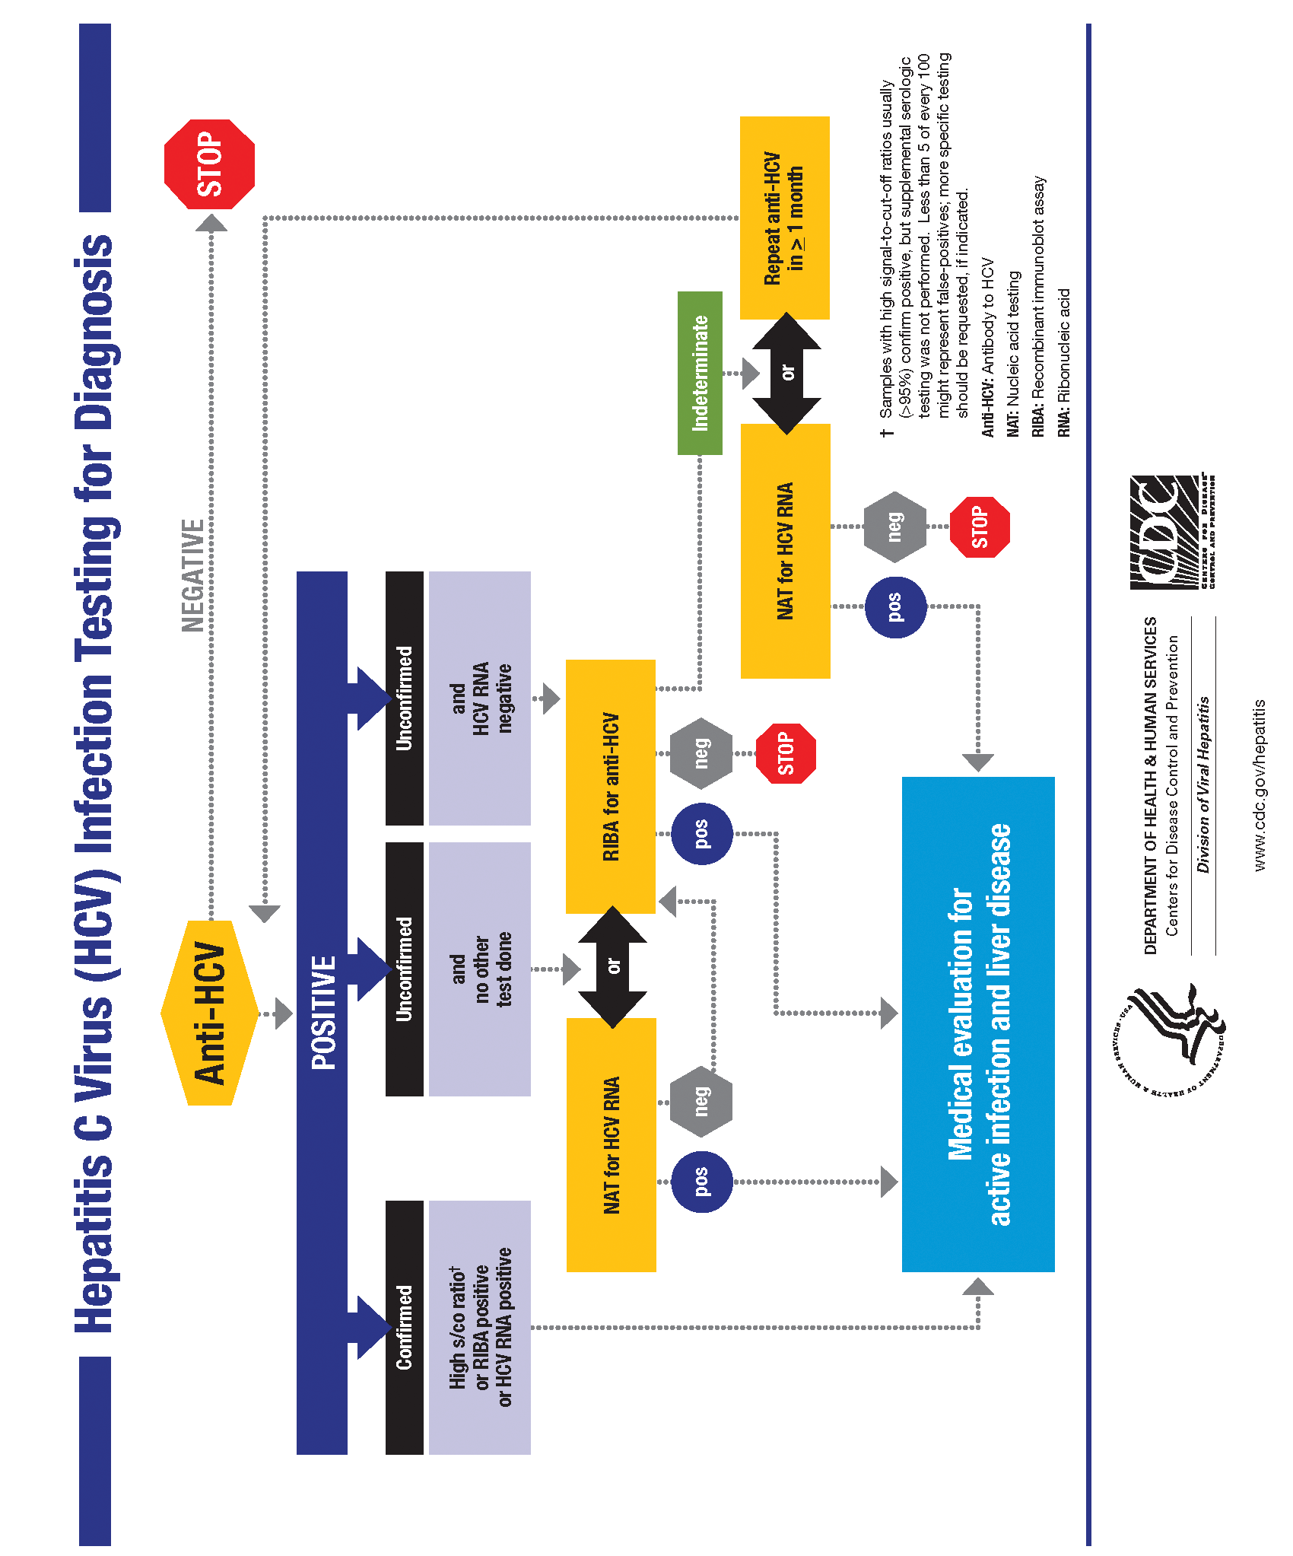

Appendix H
CDC HCV Supplemental Testing Guide

Screening Test* Kit Name | Manufacturer | Assay Format | Signal-to-cut-off-ratio Predictive of a True Positive  ≥ 95% of the Time
Ortho HCV Version  3.0 ELISA Test System | Ortho | EIA  (Enzyme Immunoassay) | ≥ 3.8
Abbott HCV EIA 2.0 | Abbott | EIA  (Enzyme Immunoassay) | ≥ 3.8
VITROS Anti-HCV | Ortho | CIA  (Chemiluminescent Immunoassay) | ≥ 8.0
AxSYM Anti-HCV | Abbott | MEIA  (Microparticle Immunoassay) | ≥ 10.0
Architect Anti-HCV | Abbott | CMIA  (Chemiluminescent Microparticle Immunoassay) | ≥ 5.0
Advia Centaur HCV | Bayer | CIA  (Chemiluminescent Immunoassay) | ≥ 11.0

*Refer to the CDC’s website at: www.cdc.gov/hepatitis/HCV/LabTesting.htm for more information.

Support Documents and Forms
Checklist for Conducting Rapid HCV Tests . . . . . . . . . . . . . . . . . . . . . . . . . . . . . . . . . . . . . . 35
HCV Positive Enhanced Risk Assessment Tool . . . . . . . . . . . . . . . . . . . . . . . . . . . . . . . . . . . 36
Client Test Result Log . . . . . . . . . . . . . . . . . . . . . . . . . . . . . . . . . . . . . . . . . . . . . . . . . . . . . . 38
Product Information Training . . . . . . . . . . . . . . . . . . . . . . . . . . . . . . . . . . . . . . . . . . . . . . . . 40
Proficiency Testing Panel Results . . . . . . . . . . . . . . . . . . . . . . . . . . . . . . . . . . . . . . . . . . . . . 45
Investigational and Remedial Action on Unacceptable Proficiency Testing . . . . . . . . . . . . 46
Clinic Communication and Complaint Log . . . . . . . . . . . . . . . . . . . . . . . . . . . . . . . . . . . . . 47

Checklist for Conducting Rapid HCV Tests

General Test Preparation

- Conditions for testing verified (temperature and lighting)
- Expiration date verified on Pouch
- Clean, disposable absorbent workspace cover
- Manufacturer’s Stand used
- Stand is on flat level surface
- Test Device left in pouch until needed (not contaminated)
- Absorbent Packet included in Pouch
- Vial slid into Stand
- Vial is completely seated in Stand
- Two holes in back of Test Device not covered

Sample Collection and Test Procedures - Fingerstick Whole Blood Collection

- Disposable gloves worn
- Client finger cleaned with antiseptic wipe
- Finger allowed to dry thoroughly
- Second drop of blood collected
- Loop was completely filled with blood
- Loop stirred into Developer Solution
- Solution turned pink
- Pad on the Test Device touched the bottom of the vial
- Results Window faced forward
- Timer used
- Results read between 20 and 40 minutes after Test Device inserted into the vial
- Test Device read while in Developer Solution Vial
- Test results properly recorded

Checklist for Conducting Rapid HCV Tests

Sample Collection and Test Procedures - Venipuncture Whole Blood Collection

Specimen collection conducted with an EDTA, lithium heparin, sodium heparin or sodium citrate

test tube

Loop was completely filled with blood

Loop stirred into Developer Solution

Solution turned pink

Pad on the Testing Device touched the bottom of the vial

Results Window faced forward

Timer used

Results read between 20 and 40 minutes after Testing Device inserted into the vial

Test Device read while in Developer Solution Vial

Quality Control (To be conducted as per manufacturer’s guidelines)

- Kit Controls run; Date and Time
- Kit Controls verify Control Test Results match the expected results
- Good lighting used with Controls
- Test viewed good lighting conditions
- Clinic room temperature checked and recorded

Comments:

HCV Positive Enhanced Risk Assessment Tool

    - Did you receive a blood transfusion or solid organ transplant (heart, lung, liver, pancreas, kidney) before July 1992?

    - Did you receive clotting factor concentrates produced before 1987?

    - Have you ever received hemodialysis?

    - Have you had blood tests that showed a liver problem?

    - Have you had a needlestick injury working in a health care setting?

    - Did your mother have hepatitis C when you were born?

    - Have you shared a toothbrush, razor, or any other item that might have blood on it (visible or not) with a person who has hepatitis C?

    - Have you or any of your sex partner(s) injected illegal drugs, even if it was only one time many years ago?
- No ❑ Yes

- No ❑ Yes
- No ❑ Yes
- No ❑ Yes
- No ❑ Yes
- No ❑ Yes
- No ❑ Yes

- No ❑ Yes

Clinic Name/Site Location: Name/ID Number: Date: Counselor/Tester: Date:

Comments:

OraQuick® HCV Rapid Antibody Test Client Test Result Log
Clinic Name:
Testing Location:

Result & How Result
Type of Date Client Received by:
Testing Testing Date Client Supplemental Received Counselor Test Dates Test # Lot #/Exp. Date Time Test Room Time Test Room Received Serum or Test Suppl Phone (PH) or
Client ID/Name Code/Initials mm/dd/yy Performed of Test Performed Temperature Interpreted Temperature Test Result Result Plasma Result Result in Person (IP)

First

a.m. ˚C
a.m. ˚C C
C C C C T

Serum PH

Second
p.m.
(circle one)
˚F
(circle one)
p.m.
(circle one)
˚F T
(circle one)
T T T
T or
C
Plasma
IP
(circle one)

Non- Reactive Invalid T
Reactive
(circle one)
Positive Negative

First

a.m. ˚C

a.m. ˚C C
C C C C T

Serum PH

Second
p.m.
(circle one)
˚F
(circle one)
p.m.
(circle one)
˚F T
(circle one)
T T T
T or
C
Plasma
IP
(circle one)

Non- Reactive Invalid T
Reactive
(circle one)
Positive Negative

First

a.m. ˚C
a.m. ˚C C

C C C C T

Serum PH

Second
p.m. (circle one)
˚F (circle one)
p.m. (circle one)
˚F T
(circle one)
T T T
T or
C
Plasma
IP
(circle one)

Non- Reactive Invalid T
Reactive
(circle one)
Positive Negative

First

a.m. ˚C

a.m. ˚C C

C C C C T

Serum PH

Second
p.m. (circle one)
˚F (circle one)
p.m. (circle one)
˚F T
(circle one)
T T T
T or
C
Plasma
IP
(circle one)

Non- Reactive Invalid T
Reactive
(circle one)
Positive Negative

First

a.m. ˚C

a.m. ˚C C

C C C C T

Serum PH

Second
p.m. (circle one)
˚F (circle one)
p.m. (circle one)
˚F T
(circle one)
T T T
T or
C
Plasma
IP
(circle one)

Non- Reactive Invalid T
Reactive
(circle one)
Positive Negative

First

a.m. ˚C
a.m. ˚C C

C C C C T

Serum PH

Second
p.m. (circle one)
˚F (circle one)
p.m. (circle one)
˚F T
(circle one)
T T T
T or
C
Plasma
IP
(circle one)

Non- Reactive Invalid T
Reactive
(circle one)
Positive Negative

38

OraQuick® HCV Rapid Antibody Test Client Test Result Log
Clinic Name:
Testing Location:

Result & How Result
Type of Date Client Received by:
Testing Testing Date Client Supplemental Received Counselor Test Dates Test # Lot #/Exp. Date Time Test Room Time Test Room Received Serum or Test Suppl Phone (PH) or
Client ID/Name Code/Initials mm/dd/yy Performed of Test Performed Temperature Interpreted Temperature Test Result Result Plasma Result Result in Person (IP)

Virginia Hall
X First Second
8:45

a.m.
p.m.

˚C
72.6 ˚F
9:08

a.m.
p.m.
˚C C
72.6 ˚F T
C C C
T T T
C T
T or

Serum PH
Plasma IP

#12345678

#938-LB 09/05/11
#1234567

12/23/12
(circle one)
(circle one)
(circle one)
(circle one)

Non- Reactive Invalid Reactive
(circle one)
C
T

9/5/11

Positive Negative

N/A
(circle one)

Mark Dewitt
X First Second
9:42

a.m.
p.m.

˚C
72.4 ˚F
10:10

a.m.
p.m.
˚C C
72.0 ˚F T

C C C
T T T
C T
T or

Serum PH
X Plasma IP

#12345679
#1234567
(circle one)
(circle one)
(circle one)
(circle one)
C
Non- Reactive Invalid T
Reactive

Positive
X Positive
(circle one)

#938-LB 09/05/11
12/23/12
(circle one)
9/5/11
Negative
9/16/03

Theresa Howard

X First Second

11:55

a.m.
p.m.

˚C
72.0 ˚F

12:17

a.m.
p.m.
˚C C
72.0 ˚F T

C C C
T T T
C T
T or

Serum PH
Plasma IP

#12345680

#938-LB 09/05/11
#1234567

12/23/12
(circle one)
(circle one)
(circle one)
(circle one)
C
Non- Reactive Invalid T
Reactive
(circle one)

Invalid N/A

Positive Negative
(circle one)

Theresa Howard
First Second

12:30
a.m.
p.m.
˚C
  - ˚F
a.m.
12:50 p.m.
˚C C
  - ˚F T
C C C
T T T
C T
T or
Serum PH
Plasma IP

#12345680
X

#938-LB 09/05/11 Repeat Test
#1234567

12/23/12
(circle one)
(circle one)
(circle one)
(circle one)
C
Non- Reactive Invalid T
Reactive
(circle one)

9/5/11

Positive Negative

N/A
(circle one)

First

a.m. ˚C
a.m. ˚C C
C C C C T

Serum PH

Second
p.m. (circle one)
˚F (circle one)
p.m. (circle one)
˚F T
(circle one)
T T T
T or
C
Plasma
IP
(circle one)

Non- Reactive Invalid T
Reactive
(circle one)
Positive Negative

First

a.m. ˚C
a.m. ˚C C

C C C C T

Serum PH

Second
p.m. (circle one)
˚F (circle one)
p.m. (circle one)
˚F T
(circle one)
T T T
T or
C
Plasma
IP
(circle one)

Non- Reactive Invalid T
Reactive
(circle one)
Positive Negative

39

OraQuick® HCV Product Information Training

Clinic Name/Site Location: Name: Date: Score: Trainer/Tester:

Select the best response for statements 1 through 6:

The complete storage temperature range of the OraQuick® HCV Test Kit is
(a) 2–8˚C; 36–46˚F (b)2–30˚C; 36–86˚F
  - comfortable room temperature - 15˚–37˚C; 59˚–99˚F

The complete storage temperature range of the OraQuick® HCV Kit Controls is
(a) 2–8˚C; 36–46˚F (b)2–30˚C; 36–86˚F
  - comfortable room temperature - 15˚–37˚C; 59˚–99˚F

The acceptable temperature range for performing OraQuick® HCV Test is
(a) 2–8˚C; 36–46˚F (b)2–37˚C; 35–99˚F
  - comfortable room temperature - 15˚–37˚C; 59˚–99˚F

According to the manufacturer’s instructions, the acceptable time to read the OraQuick® HCV Test Device result is
(a) 10 to 30 minutes
(b)20 to 40 minutes
(c) 20 to 80 minutes
(d)10 to 60 minutes

The three possible OraQuick® HCV Test Device result outcomes are
(a) reactive, non-reactive, borderline
(b)reactive, non-reactive, inconclusive
(c) reactive, non-reactive, weakly reactive
(d)reactive, non-reactive, invalid

The blood-filled Specimen Collection Loop
(a) should be rapidly dipped in the Developer Solution Vial and discarded
(b)should be stirred in the Developer Solution Vial and then discarded
(c) can be left in the Developer Solution Vial for up to 10 minutes and discarded
(d)should be stirred in the Developer Solution Vial and then saved until the test is complete

Select True or False for Statements 7 – 16:

When conducting an OraQuick® HCV Test Control, if the positive and/or negative control does not give the correct result(s), clients can still be tested with the OraQuick® HCV Kits.
True False

If the absorbent packet is not present when opening the OraQuick® HCV pouch, the pouch contents should be allowed to remain open for 5 – 10 minutes before using.
True False

The 2 holes in the back of the OraQuick® HCV Test Device must be covered after placing the device into the Developer Solution Vial.
True False

The built-in procedural control in the OraQuick® HCV Test Device is intended to confirm that that the patient sample has moved past the Test (T) area.
True False

The Developer Solution Vial must turn pink after adding the fingerstick whole blood sample.
True False

The OraQuick® HCV Test Device should not be removed from the Developer Solution Vial before reading the Test result.
True False

The first drop of blood from a fingerstick can be use to perform the OraQuick® HCV test.
True False

An OraQuick® HCV reactive test result is interpreted as positive test for the presence of HCV antibodies.
True False

OraQuick® HCV is currently approved for use in the U.S. with fingerstick whole blood specimens only.
True False

OraQuick® HCV Product Information Training Answer Key

- B. Storage conditions for the OraQuick® HCV Test Kits is 2–30˚C; 36–86˚F.

- A. Storage conditions for the OraQuick® HCV Kit Controls is 2–8˚C; 35–46˚F.

- C. Acceptable temperature range for performing the OraQuick® HCV Test Device is a comfortable room temperature of 15˚–37˚C; 59˚–99˚F.

- B. Acceptable times to read the OraQuick® HCV Test Device is 20 minutes to 40 minutes. DO NOT
attempt to read the test result after the 40 minute test development.

- D. The three possible OraQuick® HCV Test result outcomes is (R) Reactive, (NR) Non-Reactive and (INV) Invalid. An Invalid test result cannot be interpreted and is an indication that there was a problem running the test, either related to the specimen or the Device. A repeat test should be performed with a new Pouch and new sample.

- B. The blood-filled Specimen Collection Loop should be gently stirred in the Developer Solution Vial and then immediately discarded in a bio-hazard waste container.

- False. An absorbent packet is included in each Device Pouch to ensure that moisture levels are maintained and do not compromise the Test Device performance. The absence of an absorbent packet means that the Test Device may have been compromised during storage. Immediately discard package, device and developer vial and open a new pouch to proceed.

- False. The two holes at the back of the OraQuick® HCV Test Device are part of the design of the lateral flow system. Blocking these holes with labels and or other materials will interfere with the test development.

- True. The built-in procedural control on the OraQuick® Test Device is designed to verify that the chemistry of the test has flowed past the “T” or Test Line of the Device and that a sample was added to the Developer Vial Solution.

- True. If the blood-filled loop has been properly introduced to the Developer Solution Vial, the solution will turn a shade of pink indicating sample has been mixed.

- False. If the plasma-filled loop has been properly introduced to the Developer Solution Vial, the solution will not turn a shade of pink as plasma is typically light straw colored.

- True. The OraQuick® HCV Test Device should not be removed from the Developer Solution Vial until the test result has been read, interpreted and documented.

- False. The first droplet of blood should be wiped away from the finger. Typically, the first droplet will contain tissue sample as well as blood. This may interfere with the test performance. Apply the loop to the second droplet for a clean sample.

- True. An OraQuick® HCV Reactive test results is reported as a POSITIVE. OraQuick® HCV Rapid Antibody Test is a qualitative immunoassay test. A positive test result indicates that the presence of HCV antibodies have been detected. The patient should undergo appropriate clinical follow-up for supplemental testing.

- False. The OraQuick® HCV Rapid Antibody Test is approved in fingerstick AND venipuncture whole blood.

OraQuick® HCV Rapid Test Result Panel Training

Clinic Name/Site Location: Name: Date: Score: Trainer/Tester:

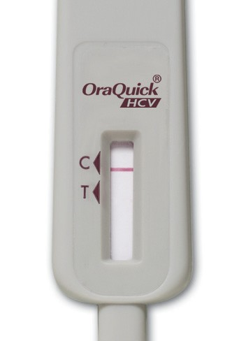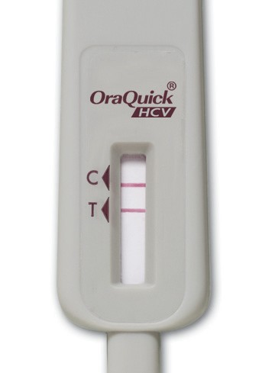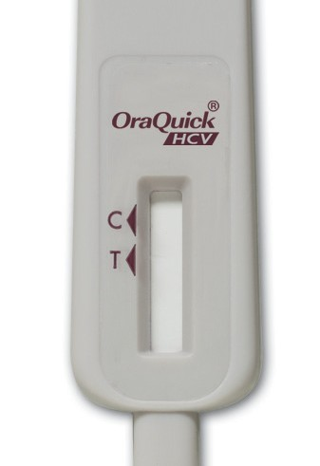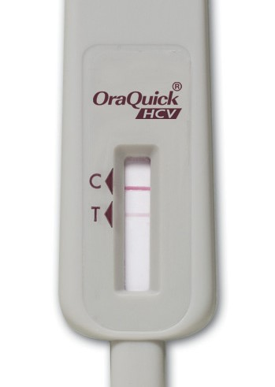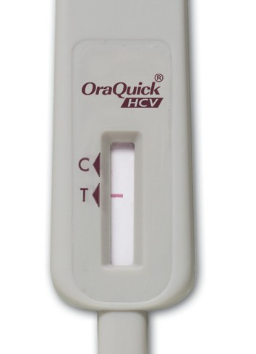
1
2
3
4
5

Result:

Result:

Result:

Result:

Result:

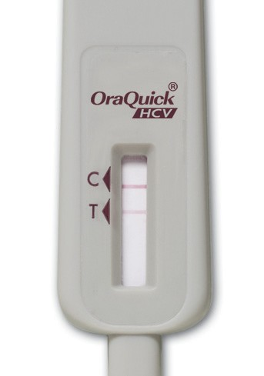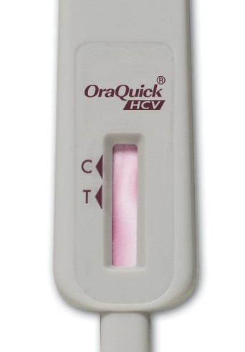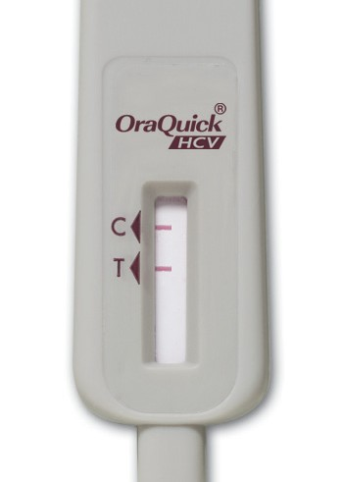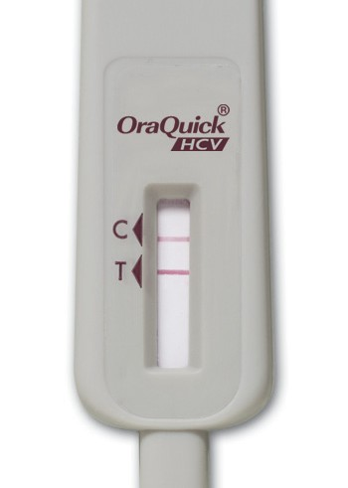
6
7
8
9
1

Result:
Result:
Result:
Result:
Result:

43
Write the Result on the line below each Test Device: Non-Reactive (NR); Reactive (R); Invalid (INV)

OraQuick® HCV Test Result Panel Training Answer Key

OraQuick® Rapid Test Result Panel Training - Answer Key

- NR. Test line appears only in the “C” designated area, indicating no detection of HCV antibodies are present at the time the test was conducted. Patient is presumed not to be infected with HCV.

- R. Test lines appear in the “C” and “T” designated areas, indicating that the presence of HCV antibodies have been detected in the specimen. The patient is presumed to be infected with HCV. The strength of the “T” line has no direct correlation to a quantitative interpretation of the HCV virus. A reactive result in the OraQuick® HCV Rapid Antibody Test should undergo appropriate clinical follow- up, according to CDC recommendations for supplemental testing.

- INV. No test lines appear in the “T” or “C” designated areas. No interpretation can be made. Repeat the test with a new Pouch and a new specimen.

- R. Test lines appear in the “C” and “T” designated areas, indicating that the presence of HCV antibodies have been detected in the specimen. The patient is presumed to be infected with HCV. The strength of the “T” line has no direct correlation to a quantitative interpretation of the HCV virus. A reactive result in the OraQuick® HCV Rapid Antibody Test should undergo appropriate clinical follow- up, according to CDC recommendations for supplemental testing.

- INV. No test lines appear in the “C” designated area and only a partial line appears in the “T” designated area. This result means there was a problem running the test, either related to the specimen or to the Device. No interpretation can be made. Repeat the test with a new Pouch and a new sample.

- R. Test lines appear in the “C” and “T” designated areas, indicating that the presence of HCV antibodies have been detected in the specimen. The patient is presumed to be infected with HCV. The strength of the “T” line has no direct correlation to a quantitative interpretation of the HCV virus. A reactive result in the OraQuick® HCV Rapid Antibody Test should undergo appropriate clinical follow- up, according to CDC recommendations for supplemental testing.

- INV. No test lines appear in the “T” or “C” designated areas. The test result window has not cleared revealing the test result rendering it impossible to read or interpret. This result means there was a problem running the test, either related to the specimen or to the Device. No interpretation can be made. Repeat the test with a new Pouch and a new sample.

- INV. Partial test lines appear inside the “T” and “C” designated areas. While on appearance, it would seem that a POSITIVE could be interpreted, the partial development of the test lines are not fully developed within the designated areas. No interpretation can be made. Repeat the test with a new Pouch and a new sample.

- NR. Test line appears only in the “C” designated area, indicating no detection of HCV antibodies are present at the time the test was conducted. Patient is presumed not to be infected with HCV.

- R. Test lines appear in the “C” and “T” designated areas, indicating that the presence of HCV antibodies have been detected in the specimen. The patient is presumed to be infected with HCV. The strength of the “T” line has no direct correlation to a quantitative interpretation of the HCV virus. A reactive result in the OraQuick® HCV Rapid Antibody Test should undergo appropriate clinical follow- up, according to CDC recommendations for supplemental testing.

Proficiency Testing Panel Results

Specimen Proficiency Panel Interpretation:
For each specimen, indicate the result with a checkmark for either REACTIVE, NON-REACTIVE, or INVALID.

Assay Lot #:
To be completed by study monitor:

Specimen A: ❑ | REACTIVE | - NON-REACTIVE | - INVALID | - CORRECT | - INCORRECT
Specimen B: ❑ | REACTIVE | - NON-REACTIVE | - INVALID | - CORRECT | - INCORRECT
Specimen C: ❑ | REACTIVE | - NON-REACTIVE | - INVALID | - CORRECT | - INCORRECT
Specimen D: ❑ | REACTIVE | - NON-REACTIVE | - INVALID | - CORRECT | - INCORRECT
Specimen E: ❑ | REACTIVE | - NON-REACTIVE | - INVALID | - CORRECT | - INCORRECT

Clinic Name/Site Location: Name: Date: Score: Trainer/Tester:

Comments:

Investigational and Remedial Action on Unacceptable Proficiency Testing

Date of Investigation: Clinic Name/Site Location: Prepared by:

Client Sample: Yes No | Control Sample: Yes No
Date of Testing: | Time of Testing:
Lot # of Test Device: | Exp. Date of Test Device:
Unacceptable (Reported) Result:
Acceptable Result Range:
Day of Testing - Quality Control Results Reviewed: Yes Acceptable Not Acceptable
Indicate Corrective Action:
Clerical/Transcription Review: Acceptable Not Acceptable
Indicate Corrective Action:
Was Patient Reported Results Affected? No, (skip to next section) Yes
Indicate Corrective Action:
Classification of Problem: Clerical Technical Methodology Problem with Client

Training Issue No Explanation
Conclusions:
Corrective Actions/System Change(s) To Prevent Recurrence:
Supervisor: |  | Date:
Lab Director: |  | Date:

Upon Completion - This Record Must be Maintained According to Local Regulations

Clinic Communication and Complaint Log

Clinic Name/Site Location:
Date Reported: | Time: |  |  | Initiated By:
Source of Communication/Complaint:
Date of Occurrence: |  |  | Time:
Narrative of Event (If necessary):
Immediate Corrective Action Taken:
Does the written procedure cover how to deal with this event? Yes No Not Applicable
*If No – Procedure must be updated within fifteen days from date of event.
If Yes – Was the written procedure followed?  Yes No |  | If No – Why not? Explain Below
Follow-up Activities Required?  Yes No |  | If Yes-Indicate what and date to be completed below
Form Completed by: |  | Date:
Signature |  | Date:
Upon Completion - This Record Must be Maintained According to Local Regulations

Clinic Communication and Complaint Log

Clinic Name/Site Location:
Schnectady Women’s Health Clinic - Schnectady, New York
Date Reported:  9/5/11 | Time:  9:50 a.m. |  |  | Initiated By:  Josephine Parker
Source of Communication/Complaint:
Kathy DeWitt’s (#1234581) Rapid HCV Screening Test revealed a “Positive” test result. Client verbally
provided Informed Consent but refuses clinical follow-up and supplemental testing.
Date of Occurrence:  9/5/11 |  |  | Time:  9:00 a.m.
Narrative of Event (If necessary):
Explained to Ms. DeWitt’s the importance of clinical follow-up appointments and the need to perform supplemental
testing for the detection of viremia as well as including importance of receiving future medical care and treatment.
Reviewed availability of local programs and further counseling information. Re-emphasized the issues of protection from
potential exposure to partner.
Immediate Corrective Action Taken:
Does the written procedure cover how to deal with this event? X Yes No Not Applicable
*If No – Procedure must be updated within fifteen days from date of event.
If Yes – Was the written procedure followed?  X Yes No |  | If No – Why not? Explain Below
Follow-up Activities Required?  Yes X No |  | If Yes-Indicate what and date to be completed below
Form Completed by:  Josephine Parker |  | Date:  9/5/11
Signature  Diane Lancer - Supervisor |  | Date:  9/5/11
Upon Completion - This Record Must be Maintained According to Local Regulations

220 East First Street Bethlehem, PA 18015
1-800-ORASURE (672-7873)
www.OraSure.com

©2011 OraSure Technologies, Inc. Item#HCV0068 (rev. 06/11)

