HCV RNA-Positive: Now What?

- Give client test results

- Go to www.imaginehope.com, under RESOURCES, click on Hepatitis Screening

Scroll down and show your client these videos:

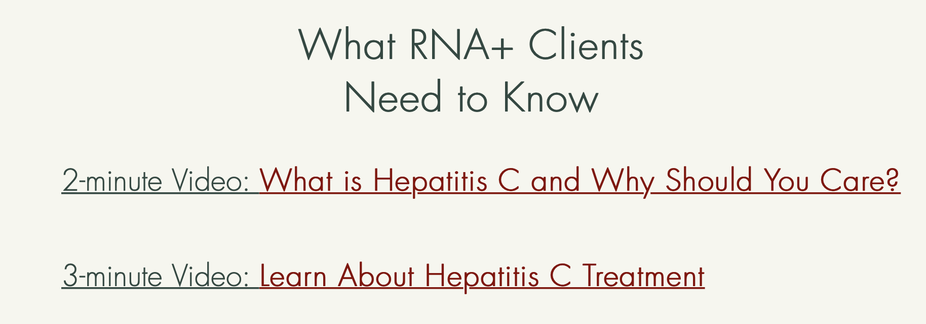

- Warm hand-off to Linkage Coordinator

o Call your Linkage Coordinator while the client is still in the office.

o Introduce the client by phone.

o Fax or email linkage package to Linkage Coordinator:

- 360 Release initialed & signed by client

- Staying in Touch form

- Quest Lab Result

